Task A:

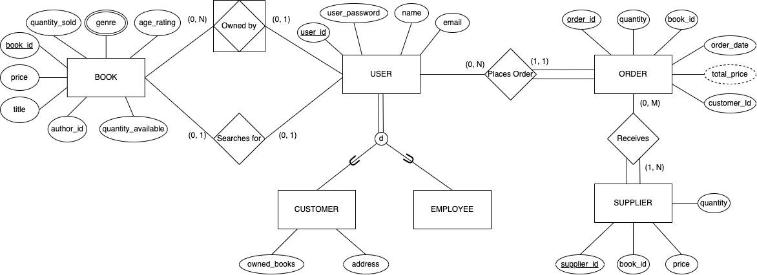

Task B:

| Relation | Primary/Foreign Keys | Attributes |
| --- | --- | --- |
| User | Primary Key:  user_id - int (10)   * Identifying register for each user (each user type would have a specific starting sequence to differentiate between users) | user_password - varchar (20)   * Password user uses to login (along with email address)   name - varchar (30)   * Full name of the user   email - varchar (50)   * Email address user uses to login (along with user_password)   Subclasses:  *Customer*   * owned_books - Null String List   + List of name of books that customer has previously placed an order for * address - varchar (100)   + Address of customer used to deliver placed orders   *Employee* |
| Order | Primary Key:  order_id - int (10)   * Identifying register for each order   Foreign Key:  customer_id - int (10)   * Identifying register for each customer   book_id - int (10)   * Identifying register for each book | quantity - int (5)   * Number of books placed in order   total_price - double (10)   * Total sum of price of books   order_date - date(MM-DD-YYYY)   * Date of which the order was placed |
| Supplier | Primary Key:  supplier_id - int (10)   * Identifying register for each supplier   Foreign Key:  book_id - int (10)   * Identifying register for each book | price - double (10)   * The price tag of each book   quantity - int (5)   * Number book(s) bought from the supplier |
| Book | Primary Key:  book_id - int (10)   * Identifying register for each book | Price - double (4)   * Cost of each book   age_rating - int (2)   * The appropriate age range for the intended audience of the book   genre - varchar (20)   * Categorizes books to assist users as they search   quantity_available - int (5)   * Tracks the number of copies available for each book   quantity _sold - int (5)   * Records the total number of copies each book sold   title - varchar (100)   * Allows users to search for the name of a book   author_id - int (10)   * Links each book to its designated author   book_id - int (10)   * Identifies each book |
| Owned_By | Foreign Keys: book_id - int (10)   * Identifying register for each book   user_id - int (10)   * Identifying register for each user (each user type would have a specific starting sequence to differentiate between users) |  |

Relational Mapping:  
